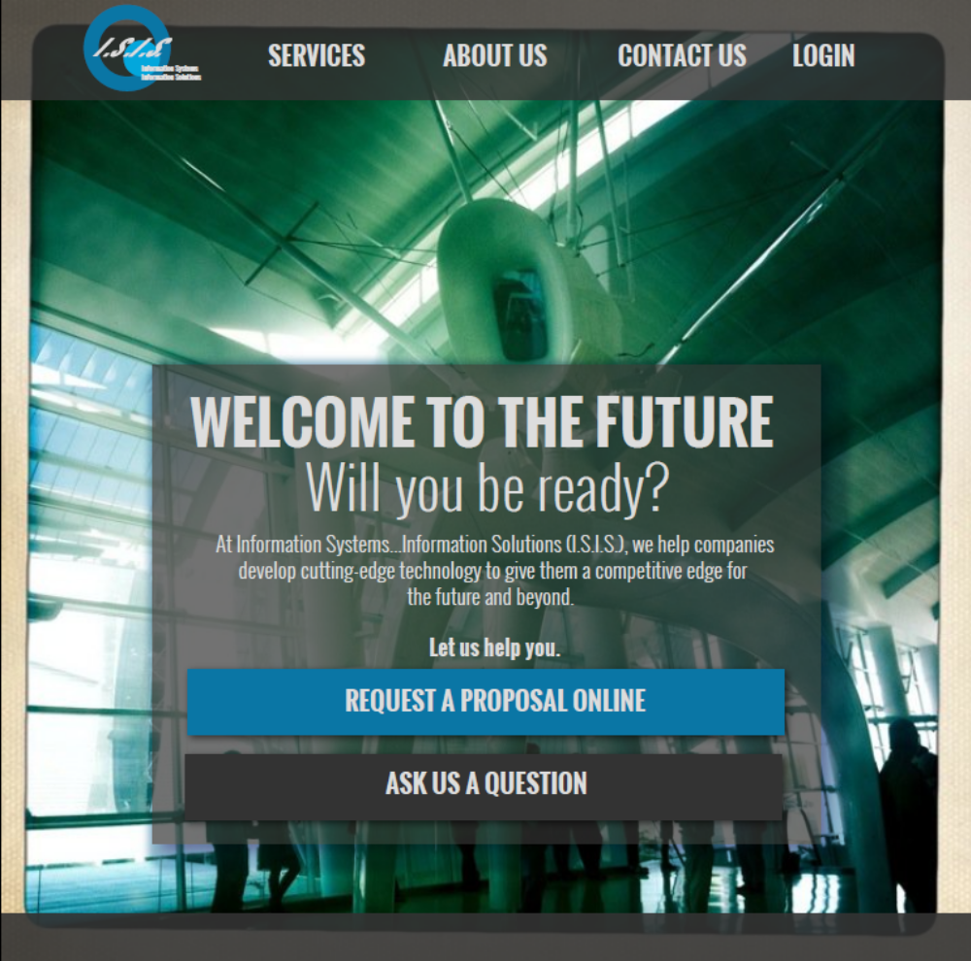
ISIS-Main-34683
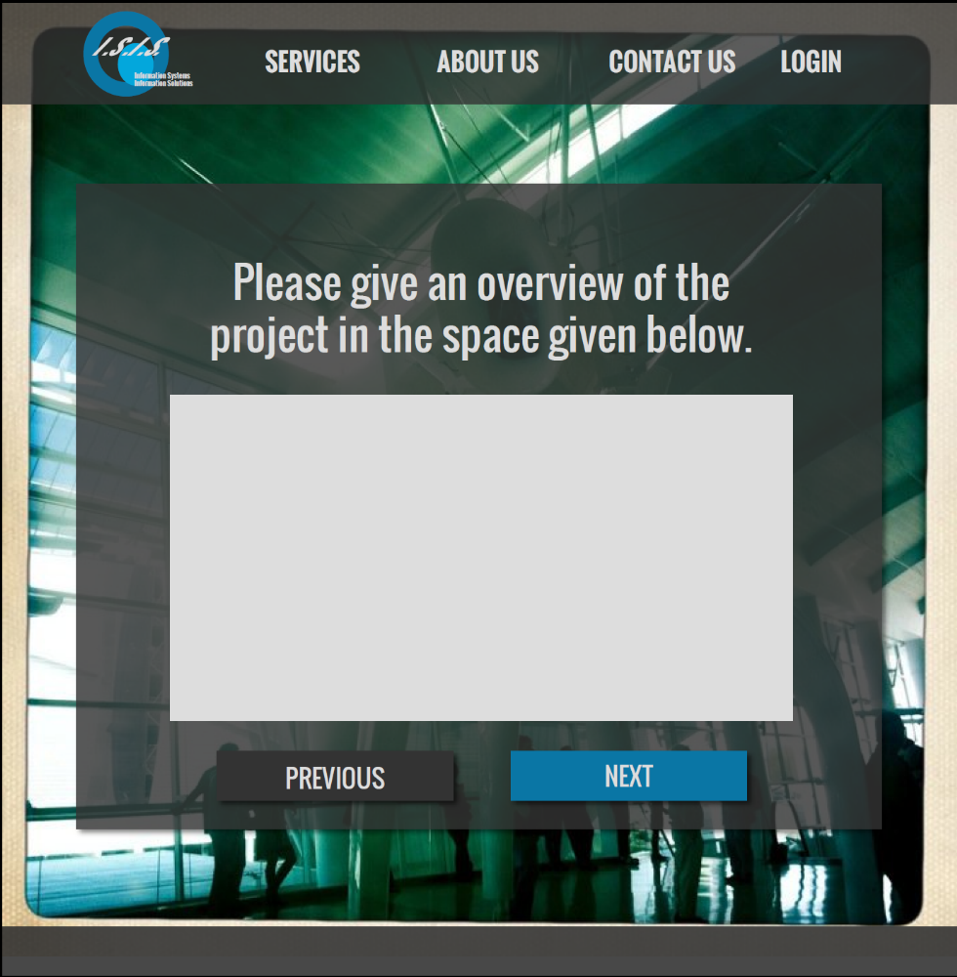
ISIS-survey-slide-92783

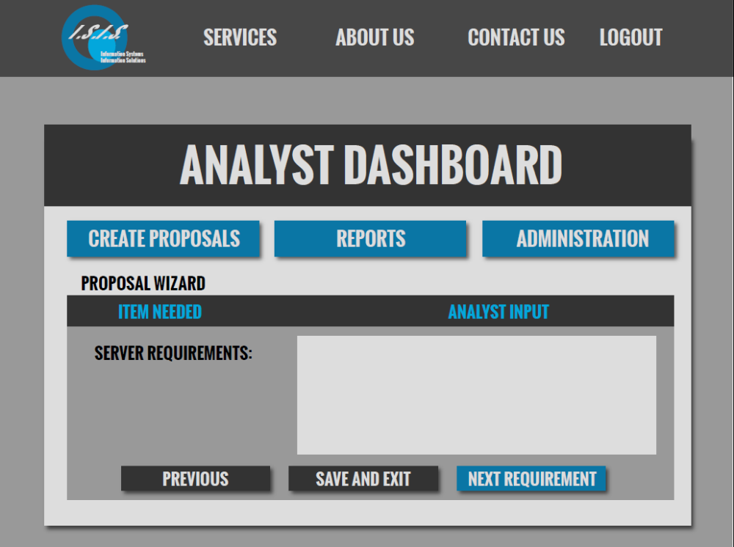
ISIS-CREATE-PROPOSAL-30704

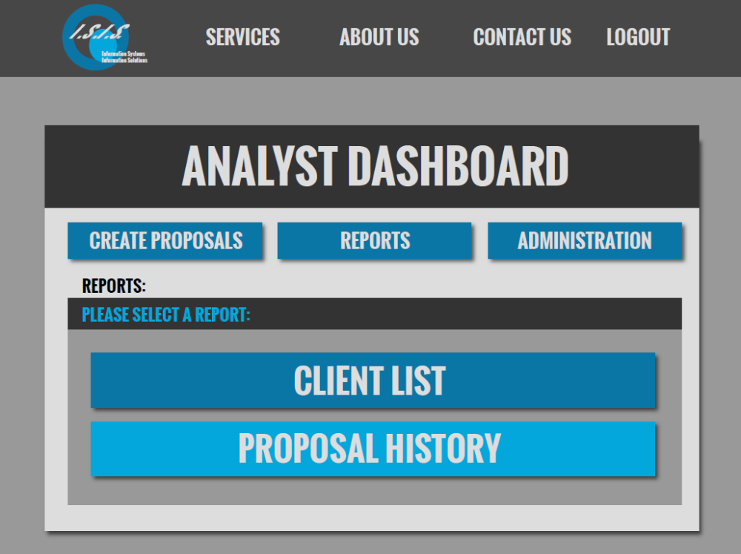
ISIS-REPORTS-MAIN-88374

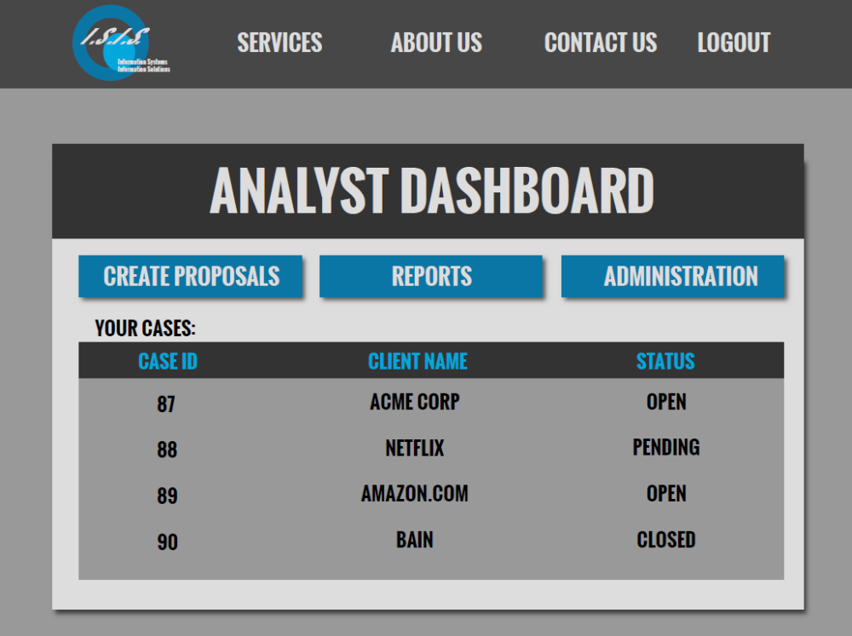
ISIS-DASHBOARD-52279

